Ex.no:4 | EXPLORATORY DATA ANALYSIS (EDA) – DATA INSPECTION, FILTERING, STATISTICAL ANALYSIS AND CORRELATION

Aim:

Algorithm:

Program:
import pandas as pd
import matplotlib.pyplot as plt

# ============================
# Import Dataset
# ============================
df = pd.read_csv("KaggleV2-May-2016.csv")

# ============================
# Dataset Inspection
# ============================
print("===== FIRST FIVE RECORDS =====")
display(df.head())

print("\n===== SHAPE OF DATASET =====")
print(df.shape)

print("\n===== DATA TYPES =====")
print(df.dtypes)

print("\n===== SUMMARY =====")
display(df.describe(include="all"))

# ============================
# Filtering Data
# ============================

# Patients aged above 60
print("\n===== PATIENTS WITH AGE > 60 =====")
senior = df[df["Age"] > 60]
display(senior.head())

# Female Patients
print("\n===== FEMALE PATIENTS =====")
female = df[df["Gender"] == "F"]
display(female.head())

# Patients who missed the appointment
print("\n===== NO SHOW PATIENTS =====")
noshow = df[df["No-show"] == "Yes"]
display(noshow.head())

# ============================
# Sorting Data
# ============================

print("\n===== SORT BY AGE (DESCENDING) =====")
sorted_df = df.sort_values(by="Age", ascending=False)
display(sorted_df.head())

# ============================
# Statistical Analysis
# ============================

print("\n===== AGE STATISTICS =====")
print("Mean :", df["Age"].mean())
print("Median :", df["Age"].median())
print("Mode :")
print(df["Age"].mode())
print("Standard Deviation :", df["Age"].std())

print("\n===== DESCRIPTIVE STATISTICS =====")
display(df.describe())

# ============================
# Grouping and Aggregation
# ============================

print("\n===== AVERAGE AGE BY GENDER =====")
gender_avg = df.groupby("Gender")["Age"].mean()
display(gender_avg)

# ============================
# Correlation Analysis
# ============================

print("\n===== CORRELATION MATRIX =====")

corr = df[
[
"Age",
"Scholarship",
"Hipertension",
"Diabetes",
"Alcoholism",
"Handcap",
"SMS_received",
]
].corr()

display(corr)

# ============================
# Visualization 1
# Average Age by Gender
# ============================

plt.figure(figsize=(5,4))
gender_avg.plot(kind="bar")
plt.title("Average Age by Gender")
plt.xlabel("Gender")
plt.ylabel("Average Age")
plt.show()

# ============================
# Visualization 2
# Age vs SMS Received
# ============================

plt.figure(figsize=(8,5))
plt.scatter(df["Age"], df["SMS_received"])
plt.title("Age vs SMS Received")
plt.xlabel("Age")
plt.ylabel("SMS Received")
plt.show()

# ============================
# Visualization 3
# Age Distribution
# ============================

plt.figure(figsize=(8,5))
plt.hist(df["Age"], bins=20)
plt.title("Age Distribution")
plt.xlabel("Age")
plt.ylabel("Frequency")
plt.show()

Output:
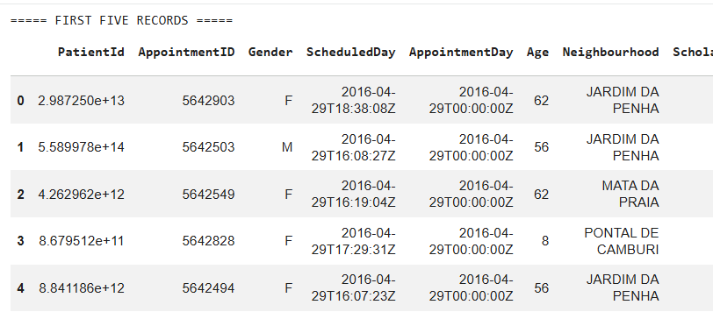
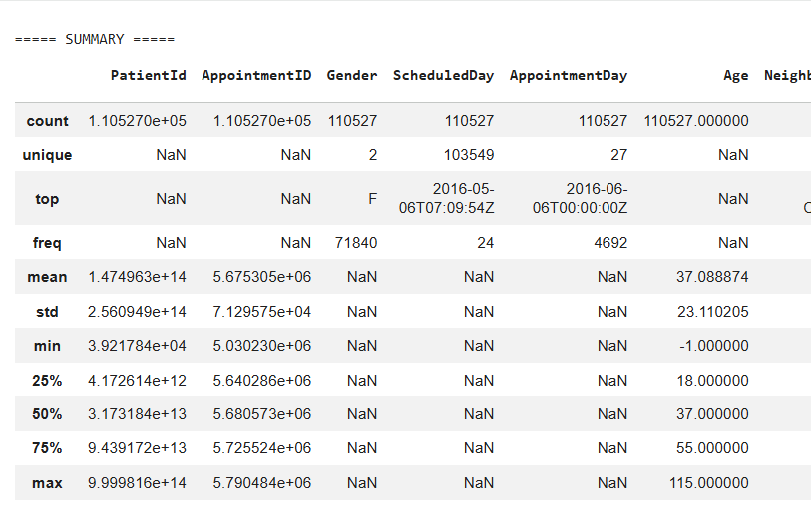
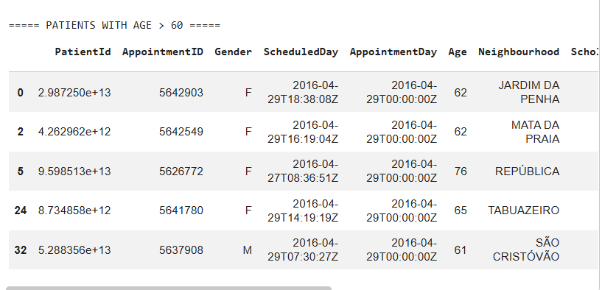

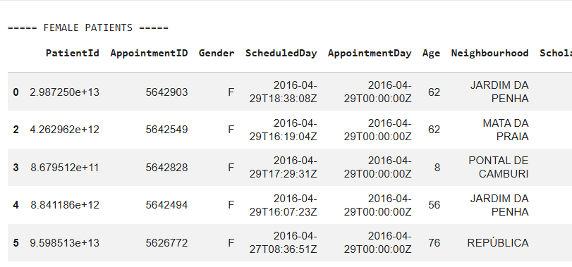
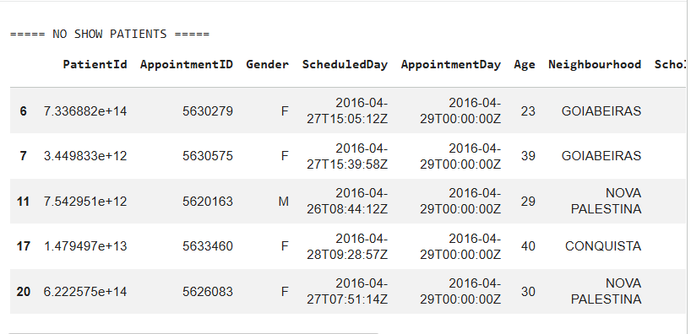
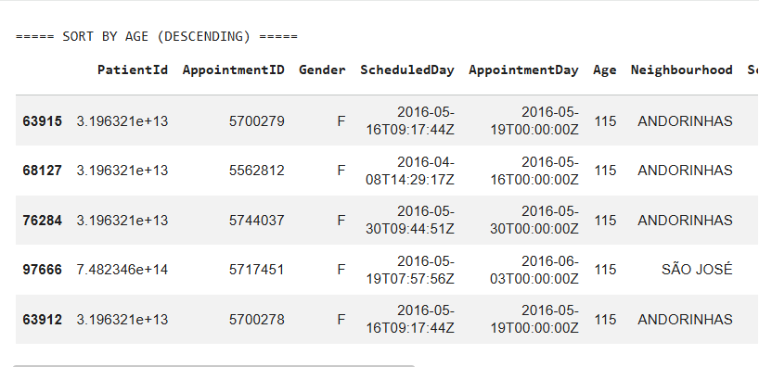

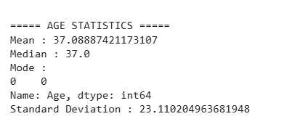

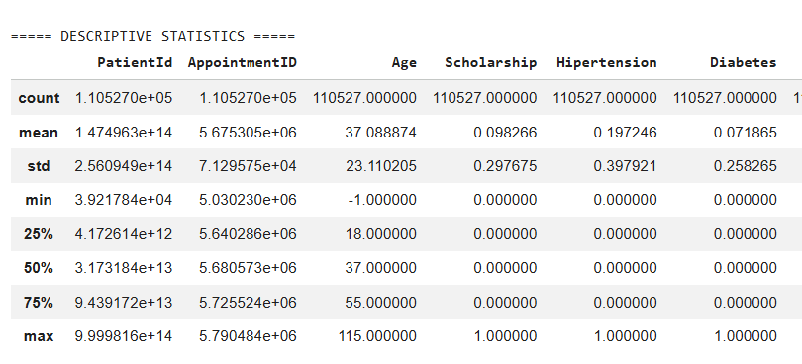
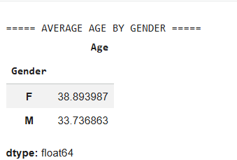

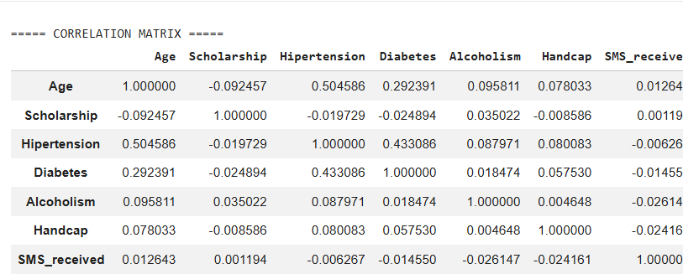
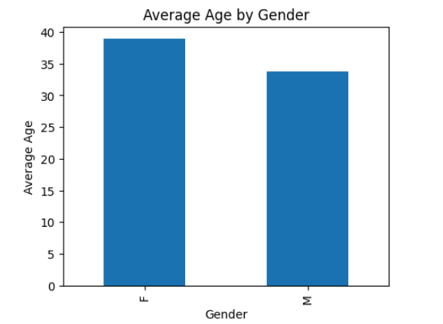

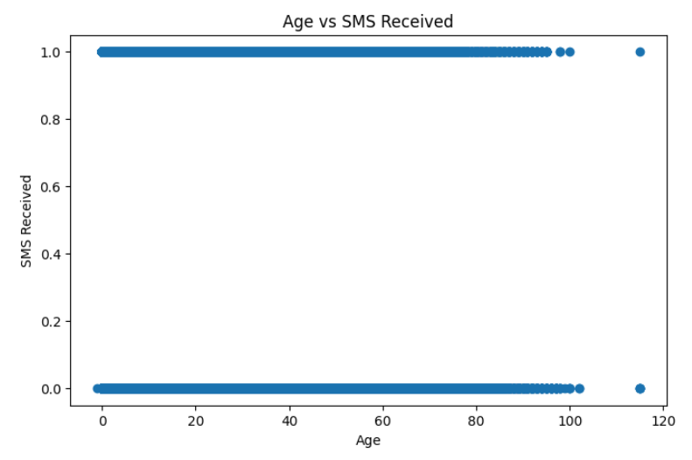

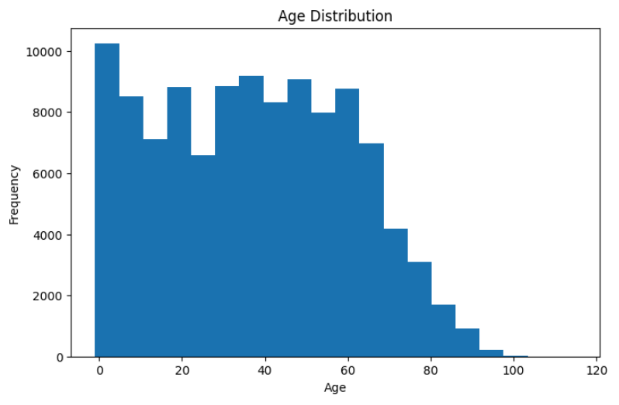

Result:

